The Sacrifices and Struggles of Life

During a quiet weekend at home, I sat down with my 67-year-old uncle. I’ve always admired for his dedication to family and work. I couldn’t resist bringing up something that had been bothering me—the struggles men like him face in trying to balance the countless demands of life. As someone just stepping into adulthood, I wanted to understand his perspective, but I also had strong opinions of my own.

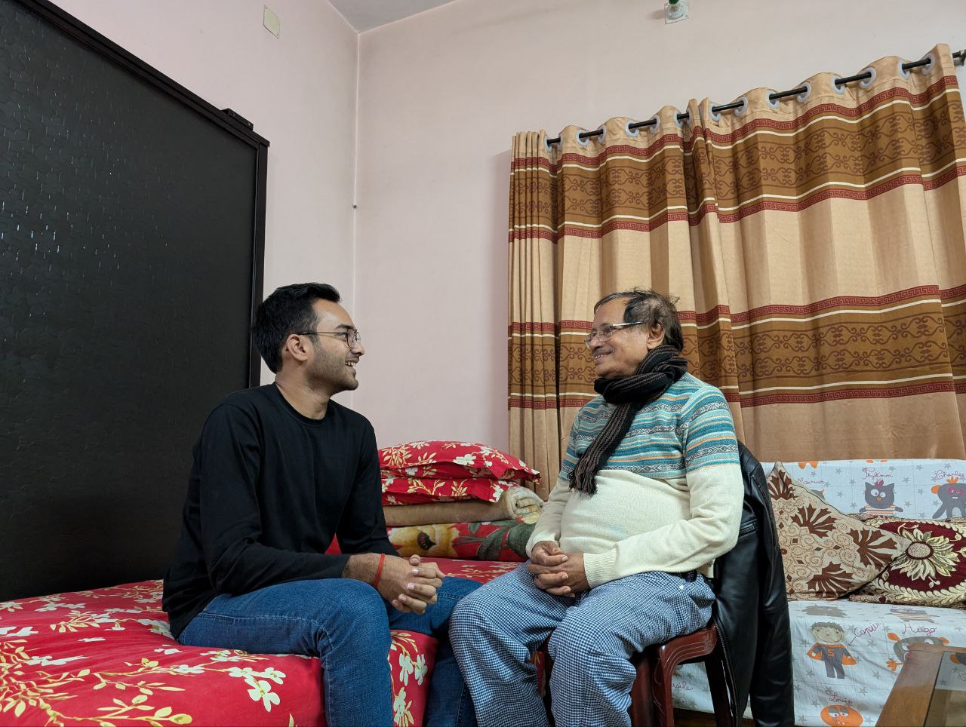

I started by sharing my thoughts. To me, it seems like men in their 60s live lives consumed by responsibilities. They juggle demanding careers, manage household expenses, and cater to their families, often at the expense of their own dreams and aspirations. It feels as if they’ve become stuck in a routine, working tirelessly to meet everyone else’s needs while sacrificing their own happiness. I questioned whether this constant grind left any room for fulfillment or personal growth.

My uncle listened carefully before sharing his side. He admitted that these years are indeed challenging, filled with sacrifices and overwhelming responsibilities. But he countered my view, saying that these sacrifices aren’t meaningless. He explained how fulfilling it is to contribute to his family’s well-being and create opportunities for his children. For him, the joy of seeing his loved ones succeed and thrive far outweighs the personal dreams he may have set aside. He argued that dreams don’t disappear—they evolve, shifting from self-centered goals to collective aspirations for those you care about.

I couldn’t help but push back. While I respected his dedication, I questioned whether such a life was truly sustainable. Constantly prioritizing others, I argued, could lead to burnout and resentment. I pointed out that balance is essential, and neglecting one’s own happiness might eventually diminish the ability to support others. I asked if he ever regretted not pursuing his own passions more actively.

He countered my argument with a knowing smile, explaining that while burnout is real, it’s lessened by the moments of connection and love that come with family life. He reminded me that personal fulfillment isn’t always about chasing dreams in isolation. Often, it’s about finding meaning in the sacrifices and building something lasting. He also pointed out that my perspective, shaped by youth, values freedom and self-expression more than stability and legacy—something that might change as I grow older.

Our conversation left me with much to think about. While I still believe balance is crucial, I began to see how the struggles of later life can lead to a deeper sense of purpose. My uncle’s perspective reminded me that fulfillment often lies not in what we achieve for ourselves, but in what we build for others.